

**AMERICAN INTERNATIONAL UNIVERSITY–BANGLADESH (AIUB)**

**Spring 2025**

**BUSINESS COMMUNICATION [FST/FE] [B]**

**REPORT**

***Data Privacy and Awareness: A Study Among Users of e-Commerce Platform in Bangladesh***

***Submitted To:***

***Tasnia Tarannum***

***Submitted by:***

|  |  |  |
| --- | --- | --- |
| NAME | ID | CONTRIBUTION |
| MD. Abrar Rafid Shariar | 22-48055-2 | |
| S.M. Rasel | 22-48039-2 |  |
| MD. Al – Imran Sayem | 22-48023-2 |  |
| MD. Tanjil Tashrik Zim | 22-48021-2 |  |

***Data Privacy and Awareness: A Study Among Users of***

***e-Commerce Platform in Bangladesh***

*Abstract*—This report aims to investigate data privacy awareness and concerns among users of e-commerce platforms in Bangladesh. The study involved surveying 56 participants using multiple-choice questions to evaluate their knowledge and behaviors regarding data collection during online purchases. A Google Form was used as the data collection tool. Results from the survey show that 71.4% of respondents are aware their personal data is collected. However, 35.7% have never read any privacy policy, mainly due to complexity and length. Furthermore, 37.5% expressed concern about data misuse, and 25% reported experiencing or suspecting a privacy breach. The study highlights the importance of increasing user awareness and implementing clearer data protection practices on Bangladeshi e-commerce platforms.

**Keywords: E-commerce; Data Privacy; Data Awareness.**

INTRODUCTION

**A. Background and Context**

The rapid growth of e-commerce has revolutionized the way businesses and consumers interact, leading to the digitalization of global trade and the establishment of virtual marketplaces [1]-[3]. Online shopping has become an essential part of modern commerce, offering consumers the convenience of purchasing goods and services from anywhere in the world. According to the latest global statistics, e-commerce has seen exponential growth, with the global retail e-commerce sales expected to surpass $7 trillion by 2025.However, there are issues with this rapid expansion as well, particularly with data privacy. Personal data such as names, addresses, and bank account information are gathered by online retailers. Inadequate protection of this data makes it vulnerable to theft and exploitation [4], [5]. Many people are not entirely aware of how their data is used or how to protect it. According to a survey, even though many people are aware of the hazards, they still fail to take adequate precautions to safeguard their personal information [6]. Therefore, it's critical that consumers and businesses understand and take seriously online privacy.

**B. Review of Existing Work**

**C. Research Gap**

While numerous studies have examined data privacy issues in the context of global e-commerce, there is limited research focused specifically on user awareness and privacy concerns within the Bangladeshi e-commerce landscape. Existing literature often emphasizes technical solutions for data protection or focuses on broader cybersecurity frameworks. However, there is a lack of empirical evidence on how Bangladeshi users perceive data privacy, their understanding of privacy policies, and their behavior when sharing personal information online. Moreover, user-level awareness, emotional response to privacy threats, and practical engagement with data protection practices remain underexplored. This study seeks to fill this gap by focusing on the knowledge, perceptions, and attitudes of e-commerce users in Bangladesh regarding personal data privacy.

**D. Research Objectives**

This study aims to investigate data privacy concerns and awareness levels among users of e-commerce platforms in Bangladesh by focusing on the following objectives:

* To assess the level of awareness among Bangladeshi e-commerce users regarding the personal data collected during online transactions.
* To examine how well users understand and engage with the privacy policies provided by e-commerce platforms in Bangladesh.
* To identify the types of personal data most commonly shared by users on Bangladeshi e-commerce platforms.
* To explore users’ perceptions and concerns about the risks of data theft or misuse during online shopping.

E. **Overview**

1. **Methodology**

**A. Research Design**

This study adopted a **quantitative approach** using primary data to investigate public awareness and perceptions regarding the use of renewable energy in daily life. The research was designed to gather insights from both university students and the general public through a structured survey.

**B. Setting and Sampling**

The survey was conducted among students at the American International University–Bangladesh (AIUB) as well as other general individuals. A total of **72 participants** took part in the study. The sample included **20 university students**, selected through voluntary sampling, while the remaining participants were recruited from the general public. All participants were invited to respond voluntarily.

**C. Data Collection Methods**

Data was collected using a **Google Forms questionnaire** designed with multiple-choice questions to facilitate quick and consistent responses. The survey gathered data on participants' awareness, opinions, and usage patterns of renewable energy in their daily lives. Basic personal information was also collected to contextualize the responses.

**D. Data Analysis Procedures**

The collected data was compiled and analyzed using **descriptive statistics**, including percentages and frequency distributions, to identify key trends and opinions related to renewable energy use.

**E. Ethical Considerations**

The study was conducted with strict attention to ethical standards. Participation was **voluntary** and the survey was **anonymous**. No personally identifiable information was collected, and participants were informed about the purpose and confidentiality of the research before providing their responses.

1. Results

.

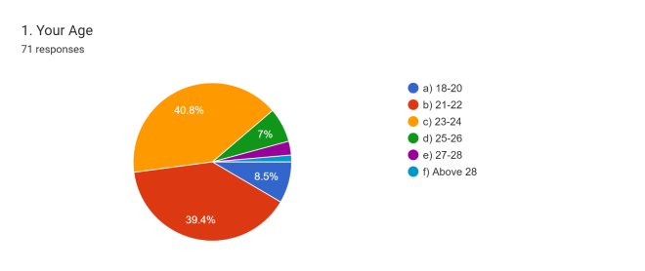

Fig 1: Age of the participants

Figure 1 shows the percentage of the age of the participants of this survey. Most of the participants of this survey have ages between 23 and 24 and they constitute about 40.8% . The second-largest group of participants has an age between 21 and 22 and they cover about 39.4%. The rest of the people are around the age of 18 to 20 and 25 to 26 they cover 8.5% and 7% respectively of this survey.

.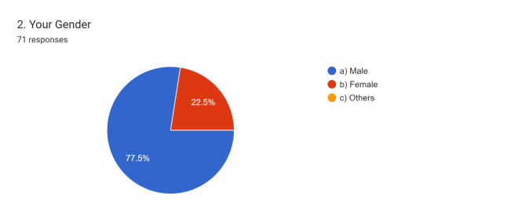

Fig 2: Gender of the participants

Figure 2 tries to figure out the percentage of the gender of the participants of this survey. Most of the participants of this survey are male which generates About 77.5% of the survey. The rest of the people are female.

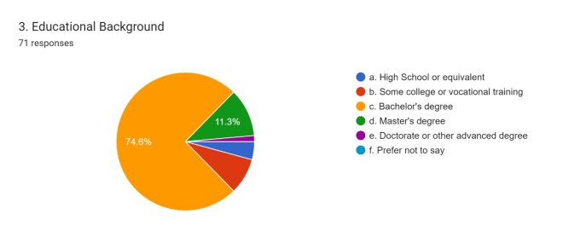

Fig 03: Educational background of the participants

Figure 03 shows the educational background of the participants of this survey. Most of the participants in this survey are bachelor's degree student and they constitute 74.6 % of the survey. The second largest are Master's degree student and they constitute 11.3%.The rest of participants are high school, college, doctorate or other advanced degree student.

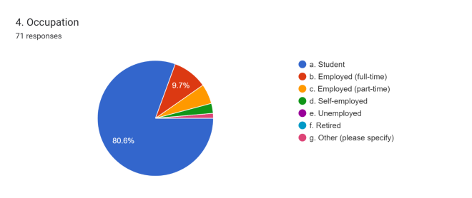

Fig 04: Occupation of the participants

Figure 04 shows the occupation of the participants of this survey. Most of the participants in this survey are student and they constitute 80.6 % of the survey. The second largest group are full time employee and they constitute 9.7%. The rest of participants are part time employee, self- employed, un-employed and retired person.

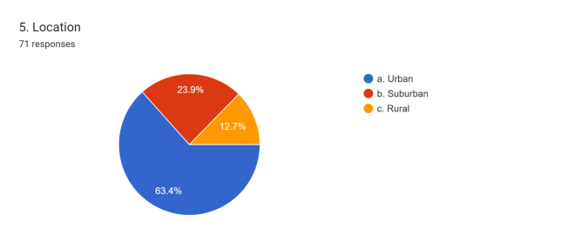

Fig 05: Location of the participants

Figure 05 shows the location of the participants of this survey. Most of the participants of this survey lives in urban areas which constitutes 63.4%. The second largest group are sub urban area residents which contributes 23.9% of this survey. The rest of the participants lives in rural area which are 12.7% of this survey.

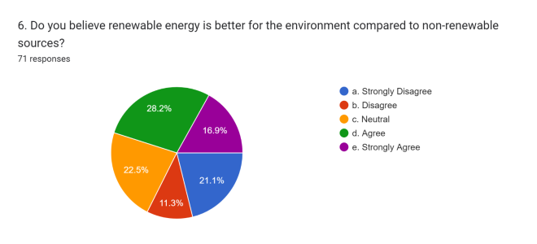

Fig 06: Opinion about whether renewable energy is better for environment compared to the non - renewable sources

Figure 06 shows about people's belief about whether renewable energy is better for environment compared to the non - renewable sources. It is illustrated that 28.2 % people agree about renewable energy is better which generates the most opinion. 22% people remain neutral about their opinion which is the second largest opinion . 11.3% people are not convinced with renewable energy being better than non - renewable sources.

.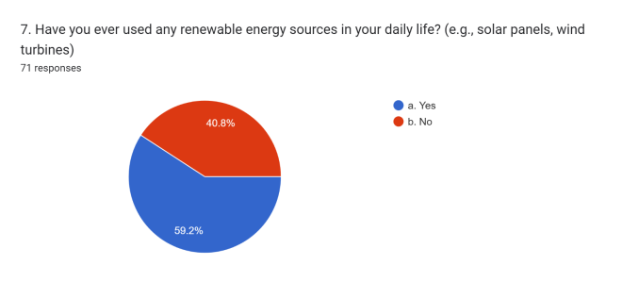

Fig 7 : Renewable energy user in their everyday activities.

Figure 7 shows about the percentage of renewable energy user in their everyday activities. Most of the participants are user of renewable energy sources which is 59.2%. 40.8% people did not use renewable energy source in their everyday activities.

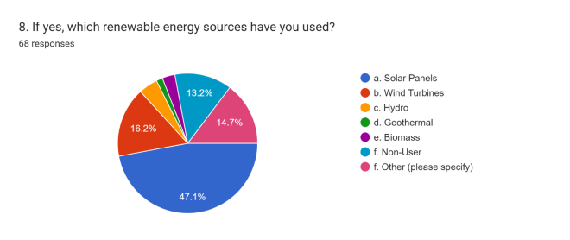

Fig 8: Different type of renewable energy users

Figure 8 shows about the percentage of different type of renewable energy users who used a source. Most of the participants are used solar energy system. They constitute about 47.1%. According to this chat, 16.2% people used Wind turbines type renewable energy sources. 14.7% people used other relevant type renewable energy sources.13.2% participants did not used any kind of renewable source.

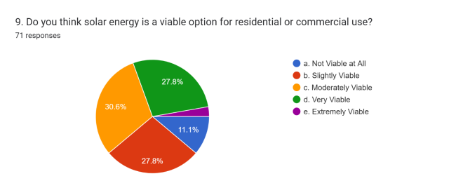

Fig 9 : Percentage of solar energy is a viable option for residential and commercial use

Figure 9 shows about the percentage of solar energy is a viable option for residential and commercial use. 30.6% people think it is moderately viable which is the most given opinion. While there was equal opinion about solar energy being slightly viable and very viable which is 27.8% . 11% people are not a believer of solar energy as a viable option

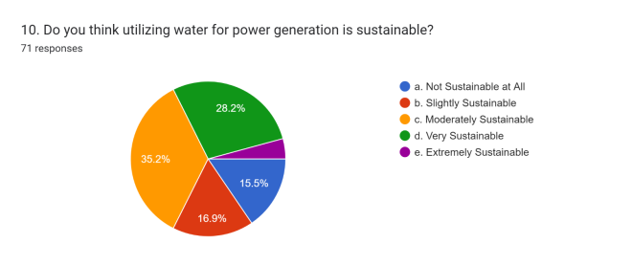

Fig 10: Percentage of utilizing water for our generation is sustainable

Figure 10 shows about the percentage of utilizing water for our generation is sustainable. The highest number around 35.2% people find its moderately sustainable. The second largest number of people find it as very sustainable which is 28.2%. 15.5% people think it is totally unsustainable whereas 16.9% people found it slightly sustainable. on the other hand , few people think it as extremely sustainable.

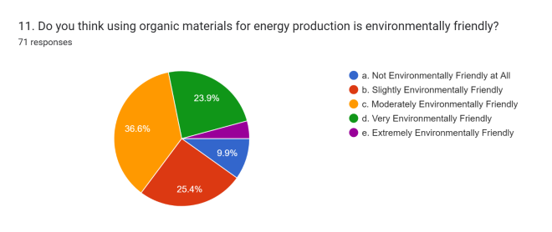

Fig:11: Organic materials for energy production

Figure 11 shows about the percentage of the organic materials for energy production is environmentally friendly. Most of the participants of this survey have moderately environmentally friendly which is 36.6%. The second largest group of participant is slightly environment friendly which is 25.4%.The most lowest participant is not environmental friendly at all which quantity 9.9%.the rest of the participant are very environmentally friendly and extremely environmentally friendly.

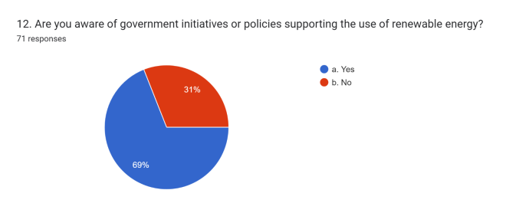

Fig 12: Policies supporting the use of renewable energy

Figure 12 shows about the percentage of aware of government initiatives of policies supporting the use of renewable energy. Most of the participant of this survey replied yes which the percentage is 69% .On the other hand, rest of the participants Replied no which percentage is 31%.

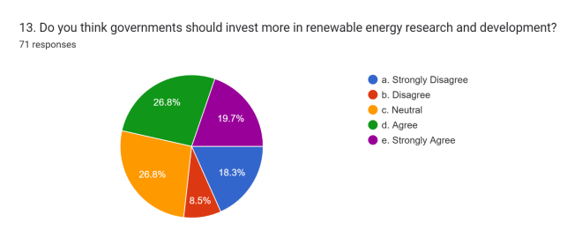

Figure 13: Peoples opinion on government required investment in renewable energy research and development

Figure 13 shows public opinion on government investment in renewable energy R&D. Both **"agree"** and **"neutral"** responses were most common at **26.8%** each, followed by **19.7%** who **strongly agreed**. The remaining participants **disagreed**, indicating limited opposition. Overall, the results suggest moderate to strong public support for government involvement in renewable energy research.

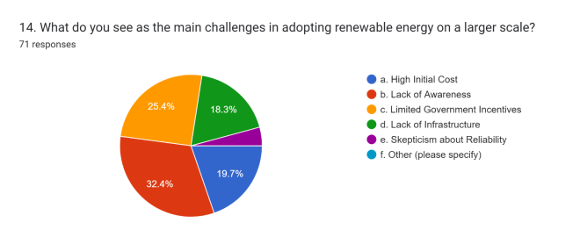

Fig 14: Primary obstacles impeding the widespread embrace of renewable energy

Figure 14 highlights the key barriers to renewable energy adoption, with the most cited being a lack of awareness (32.4%), followed by insufficient government incentives (25.4%), high initial costs (19.7%), infrastructure limitations (18.3%), and concerns about reliability (4%). These findings indicate that beyond technical and financial hurdles, informational and policy-related factors play a critical role in shaping public adoption. Addressing these challenges through a combination of education, supportive policies, and targeted investments is essential to accelerate the transition to renewable energy.

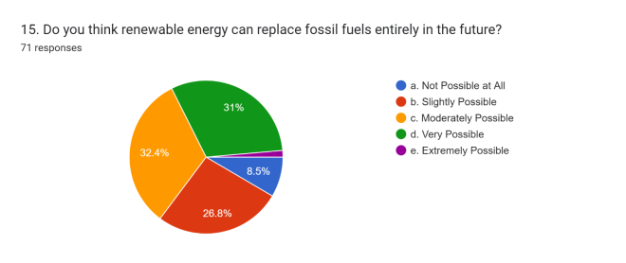

Fig 15: Varied viewpoints regarding the potential for renewable energy to replace fossil fuels

Figure 15 displays varied viewpoints regarding the potential for renewable energy to entirely replace fossil fuels. Approximately 8.5% of participants doubt its feasibility, while 26.8% see it as somewhat achievable. A larger segment, at 32.4%, regards it as moderately possible, and 31% believe it's highly achievable. A smaller but hopeful 2% believe it's extremely attainable. These diverse opinions reflect a spectrum of perspectives on the possibility of shifting entirely from fossil fuels to renewable sources, with a considerable portion expressing different levels of optimism.

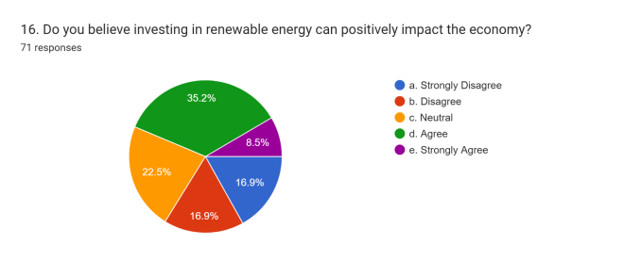

Fig 16: Whether investing in renewable energy

Figure 16 depicts opinions on whether investing in renewable energy can have a positive impact on the economy. A combined 33.8% express disagreement, with 16.9% each in the "Strongly Disagree" and "Disagree" categories. On the other hand, a substantial 43.7% hold positive views, with 35.2% agreeing and 8.5% strongly agreeing. The remaining 22.5% maintain a neutral stance. This diversity in responses highlights differing perspectives on the economic effects of renewable energy investment, with a notable proportion recognizing its potential for positive influence.

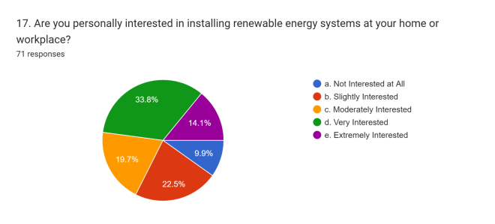

Fig 17: Installing renewable energy systems at home or work.

Figure 17 reveals individual interest levels in installing renewable energy systems at home or work. A considerable 33.8% express very high interest, while 14.1% are extremely interested. Additionally, 19.7% are moderately interested, and 22.5% have a slight interest. Only 9.9% claim to have no interest at all. These responses indicate a notable overall enthusiasm for incorporating renewable energy systems, with a significant proportion expressing a strong desire to adopt sustainable energy solutions in their personal or professional spaces.

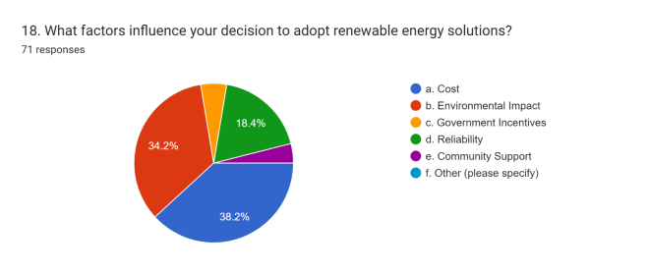

Fig 18: Solution of renewable energy

Figure 18 illustrates the factors influencing decisions to adopt renewable energy solutions. Cost emerges as a predominant consideration, with 38.2% of respondents prioritizing financial aspects. Environmental impact closely follows, with 34.2% recognizing the importance of sustainability. A smaller but noteworthy 18.4% focus on reliability, emphasizing the need for consistent energy sources. Government incentives play a role for 5% of respondents, while an equal percentage values community support. Notably, no respondents specified other factors. This distribution emphasizes the multifaceted nature of decision-making, combining economic, environmental, and communal considerations in the adoption of renewable energy solutions.

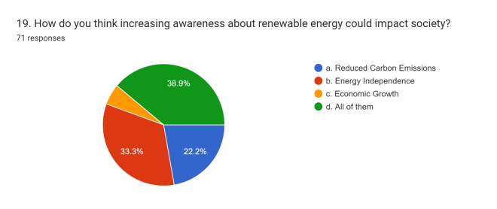

Fig 19: Awareness about renewable energy transformative impact on society

Figure 19 shows awareness about renewable energy could have a transformative impact on society. It would decrease carbon emissions by 21.9%, aiding in the fight against climate change. It could also bolster energy independence, reducing reliance on unstable sources by 34.2%. Additionally, there's potential for economic growth, indicated at 5.5%. Overall, 38.4% believe all these aspects would benefit from increased awareness about renewable energy, paving the way for a cleaner environment, more reliable energy, and economic advancement.

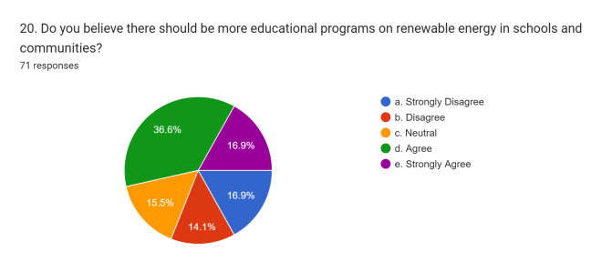

Fig 20: Necessity of incorporating renewable energy education into schools and communities

Figure 20 illustrates opinions on the necessity of incorporating renewable energy education into schools and communities. With a combined 54.2% strongly agreeing or agreeing, there's a prevalent sentiment supporting these programs. Conversely, 30.6% either disagree or strongly disagree. The remaining 15.3% hold a neutral stance. This distribution highlights a substantial inclination towards recognizing the importance of renewable energy education, indicating a growing acknowledgment of its significance in fostering environmental awareness and sustainable practices within educational institutions and local communities.

1. Recommendation

Currently 82% of the natural gas is used in the power sector for generating electricity in Bangladesh, while only 3% of the electricity comes from renewable sources. Despite this, the government of Bangladesh has unveiled a master plan to meet the increasing demand for power by focusing on future electricity generation [8]. Solar photovoltaic (PV) technology is a good option as a renewable energy source. Solar photovoltaic (PV) technology harnesses sunlight's energy directly, transforming it into electricity via solar cells comprising semiconductor materials like silicon. These panels absorb sunlight, exciting electrons within the cells and creating an electric field due to the resulting charge imbalance. This field directs the free electrons, generating a flow of direct current (DC) electricity. Collected DC electricity undergoes conversion to alternating current (AC) via inverters, making it compatible with standard electrical systems used in homes and businesses. This AC electricity can power appliances on-site or be integrated into the grid for wider distribution, exemplifying the core principle of converting sunlight into a sustainable, clean energy source. This technology advances and production scales up, the cost of solar PV continues to decrease, making it increasingly competitive with conventional fossil fuels. It also generates local jobs in installation, maintenance, and manufacturing.

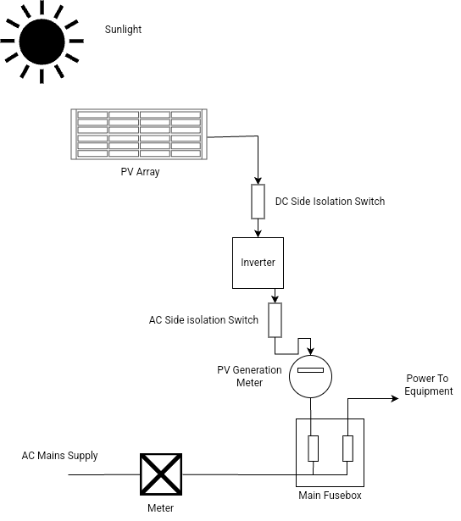

Here are some features that Solar photovoltaic (PV) technology will provide:

* Availability: Sunlight is abundant and accessible in various regions, making solar energy a widely available resource.
* Sustainability: It generates electricity without producing greenhouse gases or harmful emissions, reducing environmental impact.
* Scalability: Solar panels can be installed on a small scale (like rooftop panels) or in large solar farms, catering to diverse energy needs.
* Versatility: Solar PV can power homes, businesses, and even entire communities, contributing to a decentralized energy infrastructure.

1. Conclusion

In conclusion, the energy crisis presents an opportunity for a transformative shift towards renewable resources. Embracing this transition demands a holistic approach that combines technological innovation, supportive policies, heightened public awareness, and international cooperation. By harnessing the potential of renewable resources, societies can pave the way for a sustainable and resilient energy future, ensuring energy security while safeguarding the environment for generations to come.

VI. References

[1]. Exploitation of renewable energy for sustainable development and overcoming power crisis in Bangladesh, Journals & Books [Online], [Cited: 7 November,8.40pm]. Available: <https://www.sciencedirect.com/science/article/abs/pii/S0960148114003899>

[2]. Renewable Energy Sources in Rajasthan For Sustainable Development, IOPSCIENCE [Online], [Cited: 7 November,8.45pm]. Available: <https://iopscience.iop.org/article/10.1088/17551315/785/1/012007/meta>

[3]. Development of renewable energy sector in Bangladesh: Current status and future potentials, Journals & Books [Online], [Cited: 7 November,8.50pm]. available: <https://www.sciencedirect.com/science/article/abs/pii/S1364032117302629>

[4]. Does ICT trade facilitate renewable energy transition and environmental sustainability? Evidence from Bangladesh, India, Pakistan, Sri Lanka, Nepal and Maldives, SPRINGER LINK [Online], [Cited: 7 November,8.55pm]. Available: [https://link.springer.com/article/10.1007/s40974 020 00190 2](https://link.springer.com/article/10.1007/s40974%20020%2000190%202)

[5]. Promotion of Solar Energy Use in Bangladesh, INTERNATIONAL ENERGY JOURNAL [Online], [Cited: 7 November,9 pm]. Available: <http://rericjournal.ait.ac.th/index.php/reric/article/view/21>

[6]. IPCC Special Report on Renewable Energy Sources and Climate Change Mitigation.

Available: <Https://Www.Ipcc.Ch/Report/Renewable-Energy-Sources-And-Climate-Change-Mitigation/>

[7]. Boyle, "Renewable Energy: Power for a Sustainable Future". Available: <https://journals.sagepub.com/doi/pdf/10.1260/0144598011492723>

[8]. Renewable energy in Bangladesh: Status and prospects ,MN Uddin, MA Rahman, *, M. Mofijur , J. Taweekun, K. Techatoa, MG Rasul. ScienceDirect.com. Available:

<https://www.sciencedirect.com/science/article/pii/S1876610219313104?ref=pdf_download&fr=RR-2&rr=83cab72ac8594ea6>

Appendix

